Tutorial on how to use EPICS-Effective pairwise interactions for predicting Community Structures

This tutorial illustrates how to use EPICS, which stands for Effective Pairwise Interactions for predicting Community Structure. The method captures the effective pairwise interactions between species in the original community. For full detail, please refer to the full paper. To make EPICS readily accessible, we created an interactive MATLAB code. The code can be used to model communities that follow the generalized Lotka Volterra model or Replicator dynamics.

We demonstrate below how to use the MATLAB code for a five species gut microbial community (see the full paper for detail). The five species are *Lactobacillus plantarum* (Lp), *Lactobacillus brevis* (Lb), *Acetobacter pasteurianus* (Ap), *Acetobacter tropicalis* (At), and *Acetobacter orientalis* (Ao). We recommend keeping the data ready in excel or spreadsheet. The inputs then can directly be copied and pasted when the code asks for the inputs. Inputs however can be typed as well.

1. The code first asks for the number of species in the community.
2. The next step is to obtain the steady-state abundances of species in their respective monocultures (the carrying capacities).
3. We also need to obtain the abundances at the steady-state in each leave-one-out cultures, which are obtained by leaving each species out of the full, original culture. The table below contains these data for the five species gut microbial community.

|  |  |  |  |  |  |
| --- | --- | --- | --- | --- | --- |
| Carrying Capacity (Log10) | Lp | Lb | Ap | At | Ao |
| 5.25 | 5.626 | 5.15625 | 5.375 | 5.15625 |
|  | | | | | |
| Leave-one-out data (Log10) | Leave  Lp | Leave  Lb | Leave  Ap | Leave  At | Leave  Ao |
| Lp | 0 | 2.96875 | 1.8125 | 2.03125 | 1.75 |
| Lb | 2.90625 | 0 | 1.84375 | 2.28125 | 1.65625 |
| Ap | 0.90625 | 0.25 | 0 | 0.5 | 1.34375 |
| At | 1.25 | 0.8125 | 0.9375 | 0 | 1.1875 |
| Ao | 0.84375 | 1.65625 | 1.21875 | 1.03125 | 0 |

1. Once these inputs are fed to the code, the code estimates effective pairwise interactions between species in the community. The code also calculates the abundances in the full community using the estimated effective pairwise interactions. We reproduced below the output for the gut microbial community.

|  |  |  |  |  |  |
| --- | --- | --- | --- | --- | --- |
| Effective pairwise interactions estimated using EPICS | | | | | |
|  | Lp | Lb | Ap | At | Ao |
| Lp | -1 | 0.000457 | 0.448388 | 0.165379 | 0.115141 |
| Lb | -0.72868 | -1 | 0.528512 | -0.11965 | -0.20338 |
| Ap | 0.075218 | 0.186295 | -1 | -0.38767 | -0.79828 |
| At | -0.23096 | 0.074383 | -0.26628 | -1 | -0.58085 |
| Ao | 0.020446 | 0.06168 | 0.033159 | 0.046986 | -1 |
|  | | | | | |
| Predicted abundances in the original community using EPICS | | | | | |
|  | Lp | Lb | Ap | At | Ao |
| EPICS | 243887.2 | 220071.1 | 67269.85 | 95158.02 | 127103.7 |

1. The predicted abundances then can be compared with the experimental abundances if available.

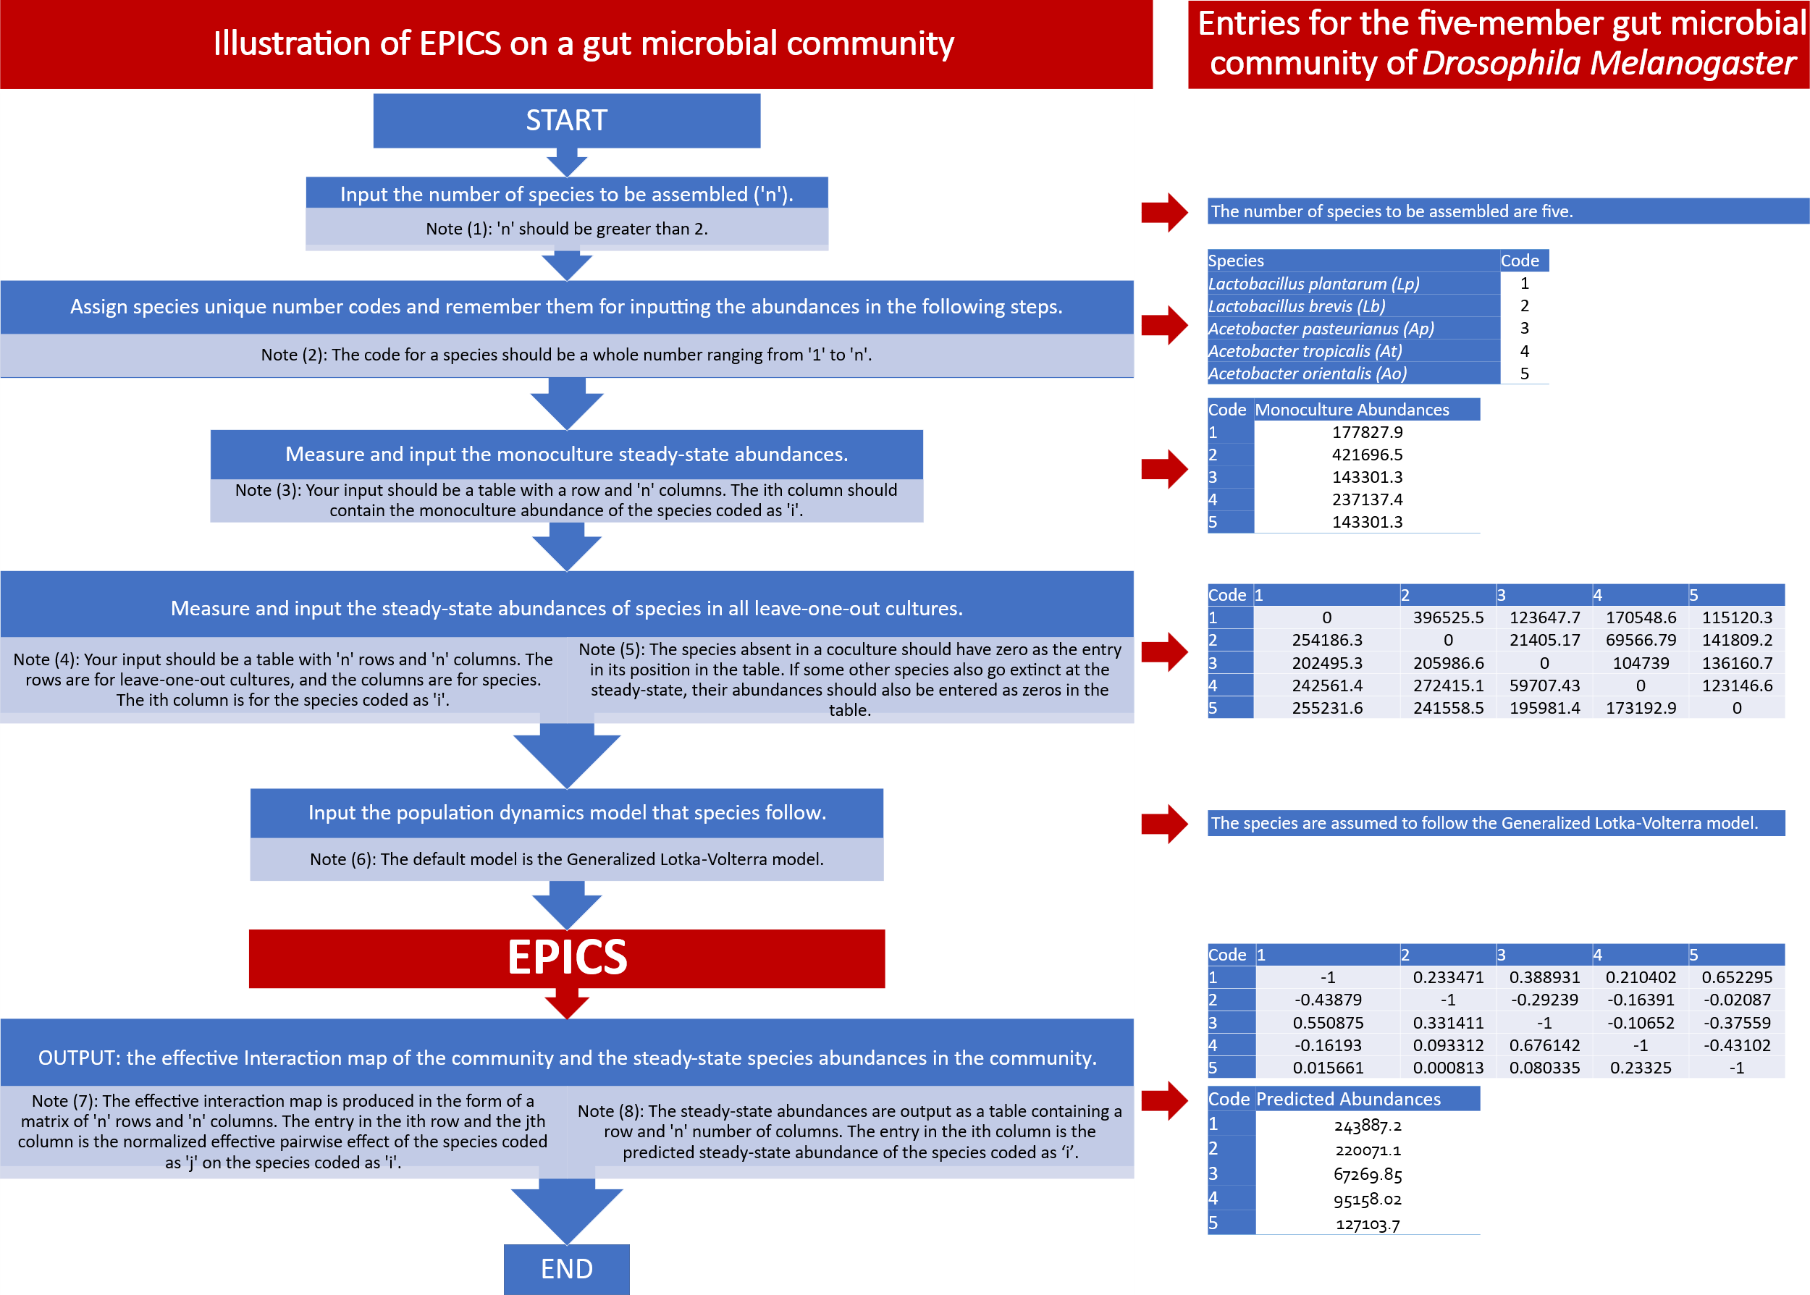

**Figure 1: Illustration of how to use EPICS using pseudo-code on a five-species gut microbial community.**

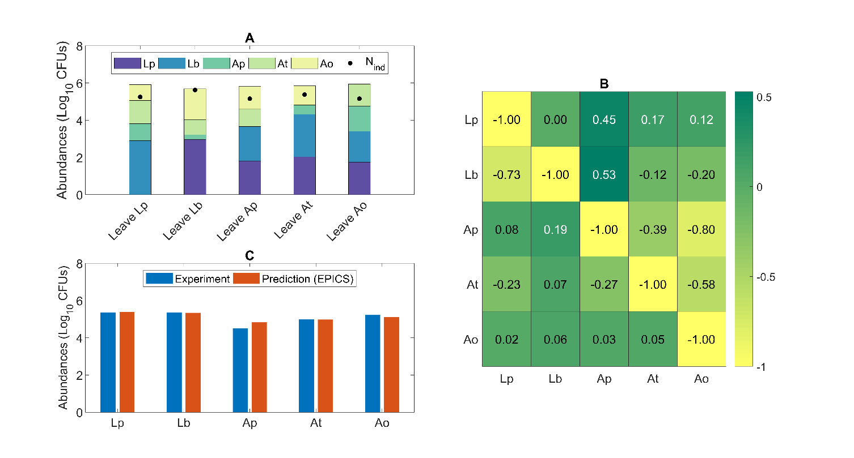

**Figure 2. EPICS captured abundances in a 5-species gut microbial community of *Drosophila melanogaster*. (A)** Measured abundances in all monocultures and leave-one-out sub-communities. The species, *Lactobacillus plantarum* (Lp), *Lactobacillus brevis* (Lb), *Acetobacter pasteurianus* (Ap), *Acetobacter tropicalis* (At), and *Acetobacter orientalis* (Ao), are color-coded. The total height of a bar for a sub-community denotes the corresponding total abundance, while the composition in the sub-community is indicated by the height of the color-coded partitions in the bar. Filled black circles are abundances in monocultures of the species indicated in the x-axis label. The leave-one-out data is presented in an expanded view in Supplementary Fig. 13. **(B)** Estimated effective pairwise interactions. Here, the interaction strengths are reported normalized by the self-interaction terms: ${\overline{A}}_{i←j}={-A}_{i←j}/A_{j←j}$. **(C)** Abundances in the 5-species community predicted using EPICS (red) and measured36 (blue).